**His Eminence Metropolitan SABA**

|  |  |
| --- | --- |
| **RT. Rev. Archimandrite Fadi Rabbat** | Rev. Dcn. Miguel ‘Michael’ Sifuentes |
| Pastor | Deacon |

**“And the Disciples were first called Christians in Antioch”. Acts 11:26**

|  |  |  |
| --- | --- | --- |
| **Tel.: 915-584-9100** | [**www.stgeorge-elpaso.org**](http://www.stgeorge-elpaso.org) | **office@stgeorge-elpaso.org** |
|  |  |  |

**“My house shall be called a house of prayer for all nations.” Mark 11:17**

**Sunday of the Pharisee and the Publican &**

**Leave-taking of the Presentation (Meeting) of Christ**

**SUNDAY, FEBRUARY 9th, 2025**

**Tone 8 / Eothinon 11**

**Saturday Vespers Service: 5:00 PM**

**Sunday Service: Orthros (Matins) at 9:15 AM, followed by Divine Liturgy at 10:30 AM**

**Sunday Epistle Reader: Dr. Raed Aldouri**

**RESURRECTIONAL APOLYTIKION IN TONE EIGHT**

From the heights Thou didst descend, O compassionate One, and Thou didst submit to the three day burial, that Thou might deliver us from passion; Thou art our life and our Resurrection, O Lord, glory to Thee.

**APOLYTIKION OF THE PRESENTATION OF CHRIST IN TONE ONE**

Rejoice, O VirginTheotokos, full of grace, for from thee arose the Sun of justice, Christ our God, lighting those who are in darkness. Rejoice and be glad, O righteous elder, carrying in thine arms the Deliverer of our souls, Who granteth us Resurrection.

**APOLYTIKION OF ST. GEORGE IN TONE FOUR**

Since thou art a liberator and deliverer of captives, a help and support of the poor and needy, a healing physician of the sick, a contender and fighter for kings, O great among Martyrs, the victory-clad George; intercede with Christ God for the salvation of our souls.

**KONTAKION OF THE PRESENTATION OF CHRIST IN TONE ONE**

Thou, O Christ God, Who by Thy Birth, didst sanctify the Virgin’s womb, and, as is meet, didst bless Simeon’s arms, and didst also come to save us; preserve Thy fold in wars, and confirm them whom Thou didst love, for Thou alone art the Lover of mankind.

**THE EPISTLE**

(For Sunday of the Pharisee and Publican)

*My soul doth magnify the Lord, and my spirit hath rejoiced in God my Savior.*

*For He hath regarded the humility of His servant.\**

**The Reading from the Second Epistle of St. Paul to St. Timothy. (3:10-15)**

Timothy my son, you have observed my teaching, my conduct, my aim in life, my faith, my patience, my love, my steadfastness, my persecutions, and my sufferings; and what befell me at Antioch, at Iconium, and at Lystra. What persecutions I endured; yet from them all, the Lord rescued me. Indeed all who desire to live a godly life in Christ Jesus will be persecuted, while evil men and impostors will go on from bad to worse, deceivers and deceived. But as for you, continue in what you have learned and have firmly believed, knowing from whom you learned it and how from childhood you have been acquainted with the sacred writings which are able to instruct you for salvation through faith in Christ Jesus.

**THE GOSPEL**

(For Sunday of the Pharisee and Publican)

**The Reading from the Holy Gospel according to St. Luke. (18:10-14)**

The Lord spoke this parable: “Two men went up into the temple to pray, one a Pharisee and the other a tax collector. The Pharisee stood and prayed thus with himself, ‘God, I thank Thee that I am not like other men, extortionists, unjust, adulterers, or even like this tax collector. I fast twice a week; I give tithes of all that I get.’ But the tax collector, standing far off, would not even lift up his eyes to Heaven, but beat his breast, saying, ‘God, be merciful to me a sinner!’ I tell you, this man went down to his house justified rather than the other; for everyone who exalts himself will be humbled, but he who humbles himself will be exalted.”

**THE SYNAXARION**

On February 9 in the Holy Orthodox Church, we take leave of the celebration of the Meeting (Presentation) of our Lord, God and Savior Jesus Christ in the Temple. On the Sunday which falls during the After-feast of the Presentation (Meeting) of our Lord, we commemorate the Holy and Righteous Mothers of the Three Hierarchs: Emmelia (Basil the Great), Nona (Gregory the Theologian) and Anthousa (John Chrysostom).

On this day, we make remembrance of the Parable of the Pharisee and the Publican, which occurs in the Holy Gospel according to Luke the Evangelist.

***Verses***

If you resemble the Pharisee, run far away from the Temple;

For inside is Christ before Whom only the humble are acceptable.

***Verses for the Triodion***

O Creator of everything heavenly and earthly, receive Thou from the Angels a Trinitarian song,

And from us men a noble and reverent Triodion.

In our Savior’s parable, Jesus uses a Pharisee, a leader of the synagogue, who was regarded in public opinion as virtuous; and a publican, a tax collector, who was regarded as oppressive, greedy and a sinner. In their prayers to God, we discover the real hearts of these two men. We thus learn of the harm that comes from pride and the good that comes from humility. The divine Church Fathers sought to alert prepare the Christ-loving clergy and laity for the upcoming period of the Great Fast. Therefore, on this Sunday we are reminded that humility is the greatest weapon against pride, as we imitate the humility of the publican to ascend to the divine heights.

Through the intercessions of the wonderworking Saints, O Christ our God, have mercy upon us and save us. Amen.

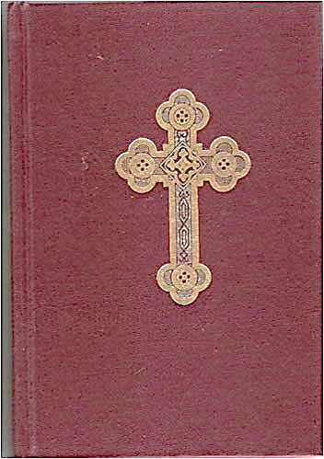**Please note for Orthros, please turn to page 44 in the Red Service Book, and to**

**page 91 to follow along with Divine Liturgy, or use the white choral music**

**booklet. Both booklets are located in the pews.**

**ONLINE LITURGICAL GUIDE FOR CHURCH SERVICES**

**Being present, prayerful and present in the church community and in the celebration of the Divine Liturgy is key to being orthodox. Please click on the following link to access the liturgical services for Saturday Vespers, Sunday Orthros, Sunday Divine Liturgy, and special services:**

[**https://www.antiochian.org/liturgicday/4094**](https://www.antiochian.org/liturgicday/4094)

**Click on the SELECT DATE in the top calendar. The services will appear under the DAILY LITURGICAL TEXT on the right column. Click on the service you need. You can follow the service using your cell phone or print a copy for your use.**

**To use your cell phone to access the above information while in church, you can link to the church’s Wi-Fi Network. Information is posted at the entrance.**

**NAMES TO BE REMEMBERED DURING THE PROSKOMEDIE & GREAT ENTRANCE**

Only the name of the donor of the Holy Bread (prosfora) and their immediate family will be read during the Great Entrance and the other listed names will be read during Sunday’s Proskomedie (the preparation of the bread and wine for the Eucharist before the Liturgy). When you send names of the living and departed to the Deacon, please indicate which names are to be remembered for the Proskomedie and those for the Holy Entrance. Again, according to our Orthodox teaching, the focus should be on remembering the names of the living and departed during the Proskomedie, where the angel takes these names remembered by the priest to the Holy Altar of God.

Traditionally, in the Orthodox church, names of the living and departed to be remembered during the Proskomedie consist only of the first name of the person(s) without the last name. Also, in accordance with Orthodox church tradition, only Orthodox Christians may be commemorated on the diskos at the Proskomedie. Also, only husband or wife of an Eastern Orthodox party can be remembered based on

*I Corinth 7: 8-16.* **For non-Orthodox Christians, living and departed, one may remember them in one’s private prayers.**

**WHO CAN RECEIVE COMMUNION IN AN ORTHODOX CHURCH?**

**Only Orthodox Christians who prepared for Communion through confession, prayer, and fasting can go up to the chalice to receive the Holy Eucharist from the priest. All visitors are welcomed to worship with us; however, non-Orthodox Christians may not partake of the Holy Eucharist but rather wait till the Dismissal of the Divine Liturgy and partake of the blessed bread (called antidoron) placed in front of the Solea.**

**Please note, do not kiss the chalice nor the priest’s hand that is holding the chalice after receiving the Holy Eucharist because it increases the risk that the chalice could be knocked a little too hard and its contents spilled.**

**It is also customary to stand in Church throughout Holy Communion and one should not leave the church until the final Blessing is given by the priest.**

**We hope this will provide a clear understanding that the unity of the Orthodox faith is the required condition to partake of the Holy Eucharist.**

**HOLY BREAD IS OFFERED BY:**

Raed & Sylvana Aldouri for our health and the health of Meena, Sarah, Austin, Mityas, Jessica, Zyla & Zena Aldouri. In celebration of Zyla's birthday (Feb 6) and Raed's birthday (Feb 22). For the health of the Aldouri family, Mary family, and Odeh family.

**DONATIONS AND MEMORIALS**

For donations made for the health of or in memory of, please make checks payable to: St. George Orthodox Church. In the purpose line write ‘Donation.’ Attach a note specifying what the donation is for. You may drop off the check(s) in an envelope at the church mailbox or mail it to: St. George Antiochian Orthodox Church, 120 N Festival Dr, El Paso, TX 79912.

You may also use the PayPal donation option located at the bottom of the church web site: [**https://www.stgeorge-elpaso.org/**](https://www.stgeorge-elpaso.org/)

Please note that in addition to making the donation for the health of or in memory of, one may also specify the donation(s) be designated towards the church maintenance account or icon project fund.  Thank you for your generous donation(s).

**DONATIONS**

Anonymous for Special Olympics.

Carol Abraham in memory of Elias, Agnes, Sidney & Bryan Abraham.

Carol Abraham for the health of Carol Abraham & family, Camille Plundo & family, Anessa Rennard & family & Matthelo Abraham.

Bryan & Annette Haddad in memory of Susana Payides.

Jamie Isaac: food for the hungry.

Jamie Isaac for the health of Jameelie Dayoub & family and for the health of Blanca Anapaikos & family.

Nabil & Doris Shaheen in memory of Susana Payides.

Dalal Young in memory of Susana Payides.

**ARCHDIOCESE DUES**

Byan & Annette Haddad Nia Isaac

**ICON FUND**

Larry & Ruth Hamilton

**TEEN SOYO FUNDRAISER**



**MARK YOUR CALENDAR FEB.13TH 5-9 P.M**

Come and support the Teens at Charcoaler.

For any questions, please contact Anne Thomas.

Thank you for your support!

**SUNDAY SCHOOL**

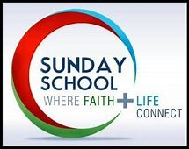

**Every Sunday students should be present at 9:25 AM to be with Fr. Fadi for the opening prayers.**

**STUDENT ATTENDANCE ROSTER FOR SUNDAY, February 2nd, 2025 – 15 students**

**Pre-School (ages 3 and 4 years old) Doris Shaheen**

Rafael Heredia & Jack Horton

**Grades Kinder/1st Jehan Al-Hanna**

Zyla Aldouri, Ezme Ferris & Knight Joudi

**Grades 2/3 Adriana Anzaldo**

Georgia Comerci

**Grades 4/5 Anne Thomas**

Andi Comerci, Dani Comerci & Kingston Joudi

**Grades 6/7 James Shaheen Jr.**

Majd Al-Dayoub & Melaina Horton

**Grades 8-12 Johnny Odeh**

Julia Encarnacion, Annabelle Horton, Nia Isaac & Amira Thomas

**Sunday School Director: Laila Ferris   
Co-Director: Anne Thomas   
Special Projects: Jaclyn Ferris   
Staff Assistant: Jorge Najera   
Staff Assistant: Kimberly Horton**

**ANTIOCHIAN HOUSE OF STUDIES (AHOS)**

Are you looking to serve the Lord in His parishes and communities?

Do you want to pursue excellence in theological education and pastoral formation?

Do you want academic theological education that leads to an intimate relationship with God?

The [Antiochian House of Studies (AHOS)](https://www.ahos.edu/) brings the ethos of the historical "School of Antioch" of the Orthodox Patriarchate of Antioch and all the East to North America. Antioch has a missionary heritage with rich ethnic and linguistic diversity to all.

As an internationally renowned program of Orthodox theological study, AHOS offers degrees accredited by the [Assn. of Theological Schools](https://www.ats.edu/) in the U.S. and Canada (ATS):

Master of Theological Studies

Master of Pastoral Care and Counseling

Master of Divinity

Doctor of Ministry

Ph.D. in Orthodox Studies

AHOS also offers the St. Stephen's Certificate in Orthodox Theology.

**Apply now through April 15, 2025, at**[**www.ahos.edu**](http://www.ahos.edu/)**.**

**EXPLANATION OF THE ICON OF THE LORD’S**

**ENTRANCE INTO THE TEMPLE**

By Rt. Rev. Archimandrite Fadi Rabbat

The icon we see before us straightforwardly reflects what the Evangelist Luke described in the second chapter of his Gospel.  
  
The fundamental elements of the icon are consistent and include:  
  
- The child Jesus.  
- The Virgin Mary, Mother of God.  
- Joseph, Mary's betrothed.  
- Simeon the Elder.  
- Anna the Prophetess.  
- An altar topped by a dome supported by four pillars. The dome represents the Almighty Lord, while the four pillars symbolize the four Evangelists.  
  
However, various schools of thought exist in the creation of icons (we refer to icons as being written, not painted), leading to a variety in the colors of garments and differences in the backgrounds of the figures, altar, and temple.  
In some icons, we depict the Lord Jesus in the Virgin Mary's arms, with Simeon the Elder awaiting their encounter; in others, Jesus is held by Simeon, who may either point to the Virgin or bless him, indicating that the meeting has taken place. The arrangement and positions of the figures can vary.  
  
Regardless of these differences, the central theme remains constant: the Lord Jesus, with the Virgin Mary, Mother of Light, behind him, facing Simeon the Elder. Jesus's face is always depicted as mature, symbolizing his divinity, suggesting his existence before the incarnation.  
  
For example, in this icon, we observe:  
  
1. Simeon the Elder respectfully carries the child: What a beautiful encounter! The ancient Simeon meets the incarnate God. He embraces the divine child, asking God to set him free to become a child in His kingdom.  
  
2. The child Jesus points to the Virgin Mary, acknowledging her as the Mother of God: She is his mother and the mother of all humanity.  
  
3. Mary bows in humility before the divine event, raising her hands in acceptance of God's will, while listening to Simeon the Elder: He foretells the cross and resurrection, and she cherishes these words in her heart, illuminated by the announcement and divine grace.  
  
4. The Mother of God's garment is dark on the outside, symbolizing divine glory, patience, and the noble struggle without weariness.  
  
5. Anna the Prophetess stands behind the Virgin, gazing at Joseph and pointing to Jesus as a sign of the prophecy's fulfillment.  
  
6. Anna wears a green garment, symbolizing new life through the Lord Jesus.  
  
7. The banner in Anna's left hand proclaims: "This child established heaven and earth; through him, all was made, and without him, nothing came into being."  
  
8. Saint Joseph holds two doves, as is customary among Jews for sacrifice and purification, also symbolizing the two natures of Jesus Christ—divine and human—and the old and new covenants.  
  
May all be renewed in holiness and blessings.

**THE KISS OF PEACE DURING DIVINE LITURGY**

At the Annual General Assembly on Sunday, January 19th, Fr. Fadi gave his message and in it he addressed conforming to Orthodox tradition, one of which is the Kiss of Peace. After the Litany, the Clergy exchange the Kiss of Peace in the altar area at the invitation of the exclamation, "Let us love one another." This sacred gesture is observed among the Patriarch, bishops, and clergy within the altar, as well as between the Deacons outside the altar in the narthex of the church. In ancient times, the faithful also participated in this Kiss of Peace, a tradition that has now only been preserved primarily by the Clergy. **From now on, during the Divine Liturgy, we will no longer say "Christ in our midst" as laity, and we will not give the Kiss of Peace.**

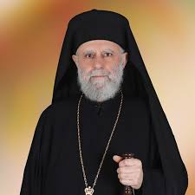**TEACHINGS FROM METROPOLITAN SABA**

Dear parishioners and friends, you will periodically be receiving teachings by His Eminence **Metropolitan Saba** as we receive them from the Archdiocese Office. The teachings will be sent under a separate church email.

**THE ADULT STUDY GROUP**

As the weeks rush by, we soon find that we are at the threshold of the Great Lent.  Are there 'requirements' for the correct observation of this important time?  If so, what are they?  How do we make the most of the time? How do we make a 'pleasing' sacrifice to God? Sometimes, as we work to 'get it right’, the process of applying ourselves to the rigors of the Great Lent can seem very difficult, even stressful.  What is required of us and what are we to do?

This short study on the parable of the Pharisee and the Publican, which, every year, the Church gives us to introduce the Triodion, (that time immediately before the Great Lent) helps get our minds 'adjusted' so that we get the most out of what the Church offers.

Refer to the full lesson associated with the Adult Study Group topic to be nourished by additional divine truths, which will be sent under a separate church email.

In Christ,

Dr. Sandra Edwards

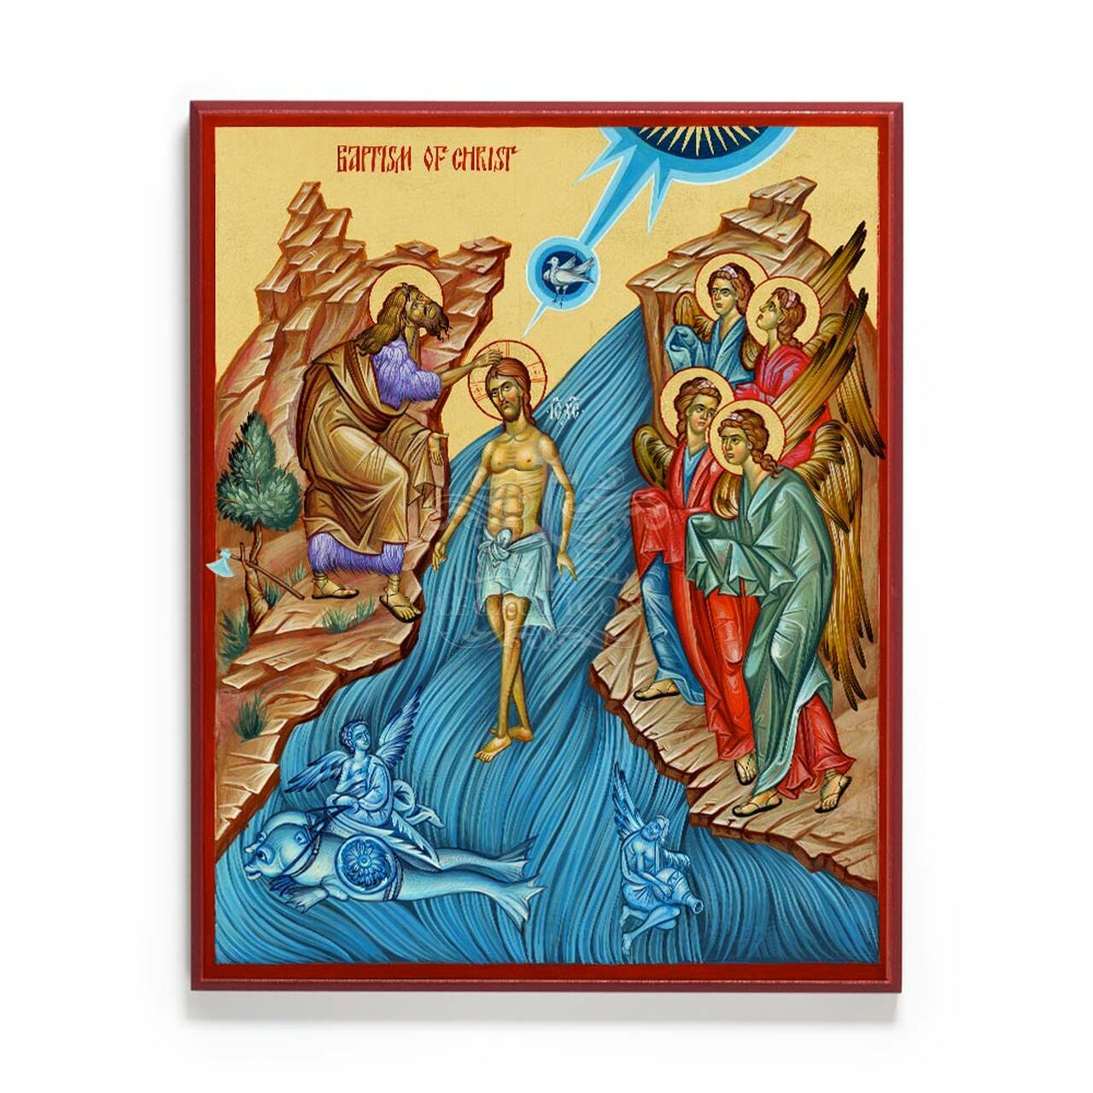 **WELCOME HOME**

“*There is one body and one Spirit, just as you were called in one hope of your calling; one Lord, one faith, one baptism; on God and Father of all, who is above all, and through all, and in you all*.” Eph. 4:4-6

We welcome little Beverly “Maria” Maus, who was Baptized to the Holy Orthodox faith on Sunday, February 2, 2025. Chosen saint's name is in "quotations". Beverly is the daughter of Kody and Beatriz Maus.

We also welcome the following who were Chrismated to the Holy Orthodox faith on Sunday, February 2, 2025:

Angello “Gabiel” Asonye-Ruiz Patrick “George” Doolin

Peter “Constantine” Diaz “James” Millican

God grant you all many years! (Psalm 91:16, Proverbs 3:16)

**COFFEE HOUR & FELLOWSHIP**

Please join us after church on Sundays for Coffee Hour in the small conference room, located in the Summit Hall.

**If you are interested in offering refreshments, please place your name on the SIGN-UP BOARD located in the small Hall**. Your name will then appear on the Refreshment Signup Sheet.

**REFRESHMENT SIGN-UP BOARD**

|  |  |  |  |  |  |  |
| --- | --- | --- | --- | --- | --- | --- |
| **Feb.9th** |  | **BORSCHOW** | **&** | **HORTON** | **FAMILIES** |  |
| **Feb.16th** |  |  |  |  |  |  |
| **Feb.23th** | **GEORGE &** | **JUDY** | **HANNA** | **JAMES &** | **ODETTE** | **SHAHEEN** |

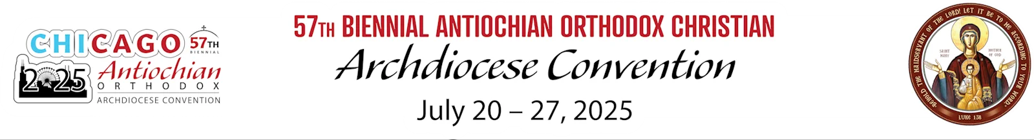

Don’t miss your chance to be a part of this historic Convention! Mark your calendar and secure your spot! For convention and hotel registrations refer to the following web site: [**www.AC2025CHICAGO.ORG**](http://www.AC2025CHICAGO.ORG)

**ST GEORGE ICON PROJECT**

## *“*…*sanctify those who love the beauty of Thy house*.”

## **From the Prayer behind the Ambon from the Divine Liturgy of St. John Chrysostom**

Icons are representations of the Heavenly. They are expressions of Orthodox

faith, teaching, and worship. The Orthodox Church uses icons to assist in worship. Icons are a ‘window to heaven' and they help us to focus on divine things.

Fr. Fadi is overseeing the Icon Project to have icons written on the bare interior walls in the church. This project continues beautifying the Church for the glory of God. **If you wish to make a monetary donation towards the Icon Project in memory of a loved one(s) and/or the health of your family, please contact Fr. Fadi at (973) 780-0221.** Please address your check to St. George Church, earmarked Icon Project Donation.

A warm thank you to all who have donated toward the Icon Project. Based on your gifts from the heart there will be more icons to come.

**PROJECT FOR THE HOLY RELIC OF ST. RAPHAEL, BISHOP OF BROOKLYN (1860-1915)**

Fr. Fadi is overseeing a new project to have an altar placed in the right alcove in the church, in front of the icon of Ss. Peter and Paul, which will consist of a carved wood stand holding the written icon of St. Raphael of Brooklyn by Odysseas Bifsas, and inside of the icon his relic, removed from the old antimension, and on each side of the icon stand two candle stands so that his relic can be venerated by the faithful. The cost of this project is estimated at around $8,000. Your gifts from the heart are graciously appreciated in support of the altar for St. Raphael of Brooklyn.

**If you wish to make a monetary donation towards the Holy Relic of St. Raphael Project in memory of a loved one(s) and/or the health of your family, please contact Fr. Fadi at (973) 780-0221.** Please address your check to St. George Church, earmarked St. Raphael Altar Project Donation.

**2025 MEMBERSHIP PLEDGE (TITHING)**

**TO ST. GEORGE ANTIOCHIAN ORTHODOX CHURCH**

*“Return to Me and I will return to you,” says the Lord Almighty….Return now in this,” says the Lord Almighty, “and see if I will not open for you the floodgates of heaven and pour out for you a blessing until it is overflowing.”* – Malachi 3:8-10

The minimum financial contribution of at least **$500.00 pledge per Baptized or Chrismated Orthodox person, ages 18 and older is required or $1000 per family (or more from the gift of the heart).** This pledge is for the maintenance of the church. You can either pay your pledge immediately, or make payments throughout the year, however, the final amount must be met by December 31st of each year. **The met pledge of $500.00 makes you eligible to vote at the Annual General Assembly of Voting Members in January 2026.** Please make check payable to St. George Church in the donated amounts. In the purpose line indicate **Church Pledge**.

If you have financial difficulties, please see the priest for available options.



**PRAYER FOR THE SICK**

Please let us know if you are ill and/or hospitalized by contacting Fr. Fadi Rabbat. We too will add your name to the prayer list for Sunday’s Divine Liturgy.

ivine Liturgy.

**CONTACT INFORMATION**

**For Pastoral needs, emergencies, visitation to hospital, homes, and communion during the year, contact Fr. Fadi Rabbat directly and not through the Deacon. Fr. Fadi will not visit without permission extended to him from the sick person or their family.**

**Confessions** are by appointment with Fr. Fadi Rabbat. **PLEASE contact Fr. Fadi TWO days in advance to ensure his schedule is free.**

**Fr. Fadi Rabbat at:**

***Cell phone***: **973.780.0221**

***Email***: **[fadi.rabbat@icloud.com](mailto:fadi.rabbat@icloud.com)**

Rev. Dcn. Michael Sifuentes at ***Cell Phone:*** (915)309-1511 ***Email:*** [**deacon@stgeorge-elpaso.org**](mailto:deacon@stgeorge-elpaso.org)

**CHURCH BULLETIN STAFF**

The RT. Rev. Archimandrite Fadi Rabbat, Chief Editor

Rev. Dcn. Michael Sifuentes, Editor

Vanessa Salloum, Assistant Editor

Jameelie Dayoub, Web Site Poster